Assignment-20.1:

Enhance the MapReduce program of Task 8 (refer session 19, assignment 3) to use multiple reducers for sorting. The driver should accept three additional values: the minimum units sold, the maximum units sold and number of reducers to use.

Use units sold as key and company as value. Write a custom partitioner to divide the keys on the basis of range. Take minimum to be 0 and maximum to be 10. Divide them across 2 reducers.

Driver Class:

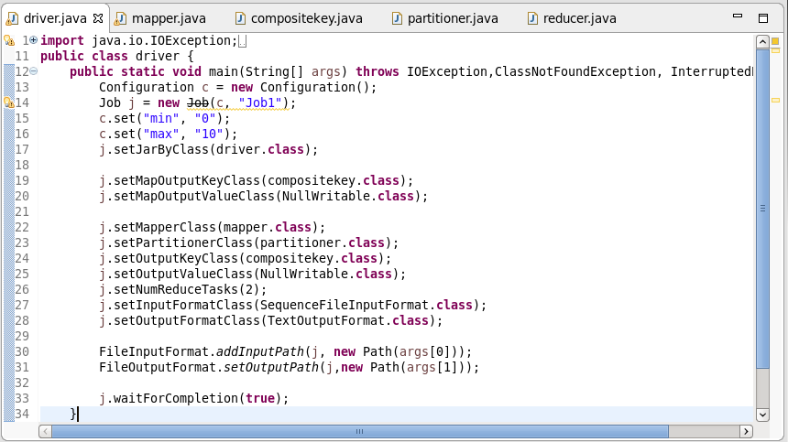

Mapper Class:

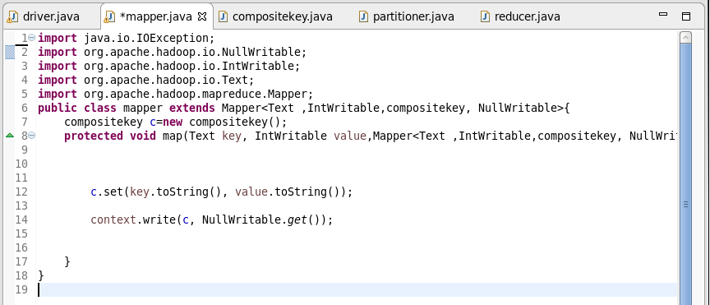

Composite Key Class:

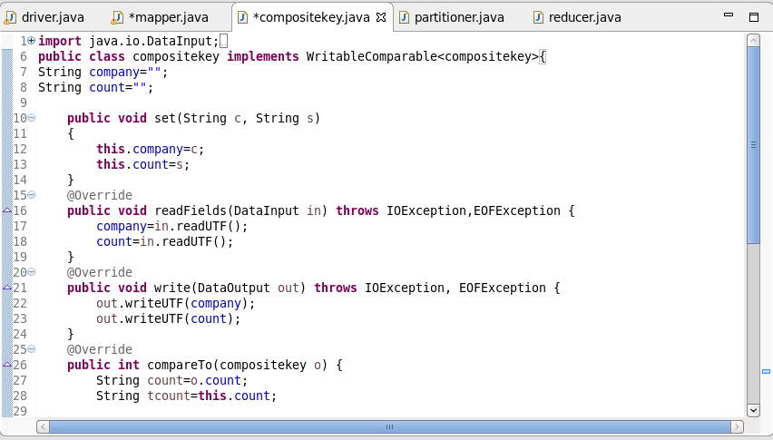

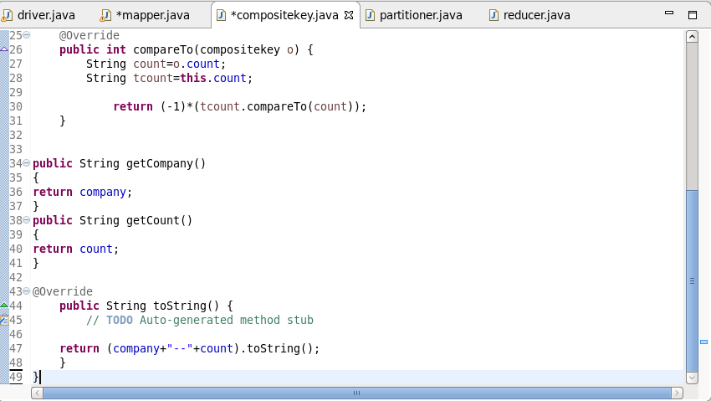

Partitioner Class:

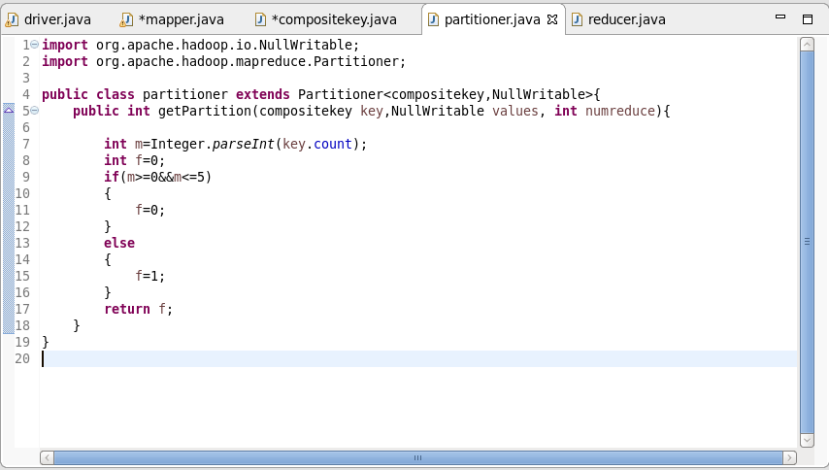

Reducer Class:

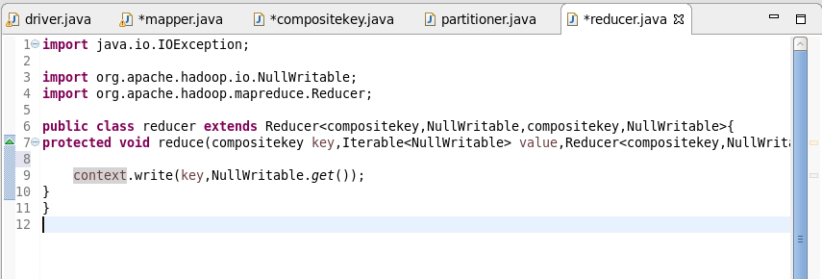

Running the Jar File:

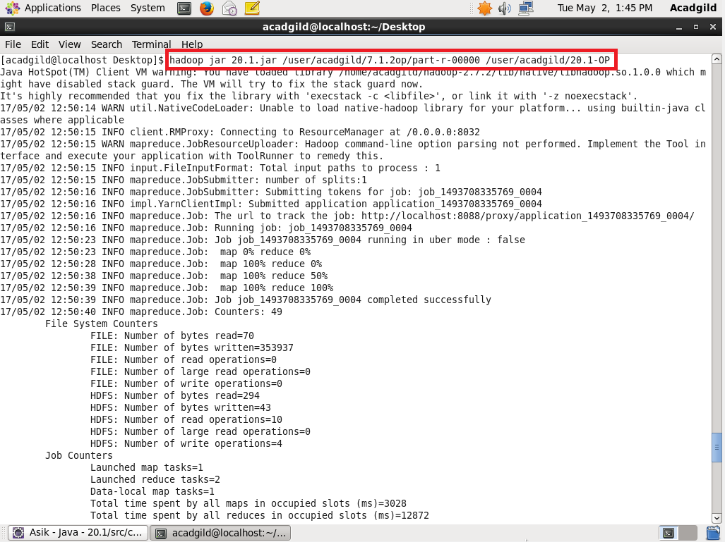

Input File:

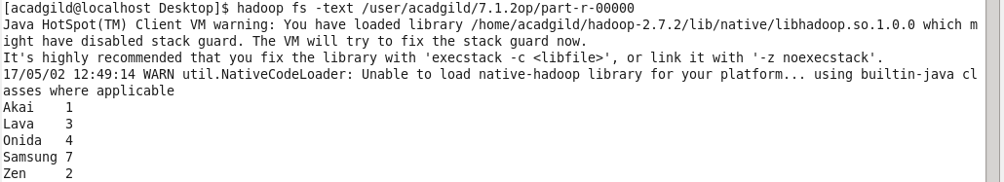

Output:

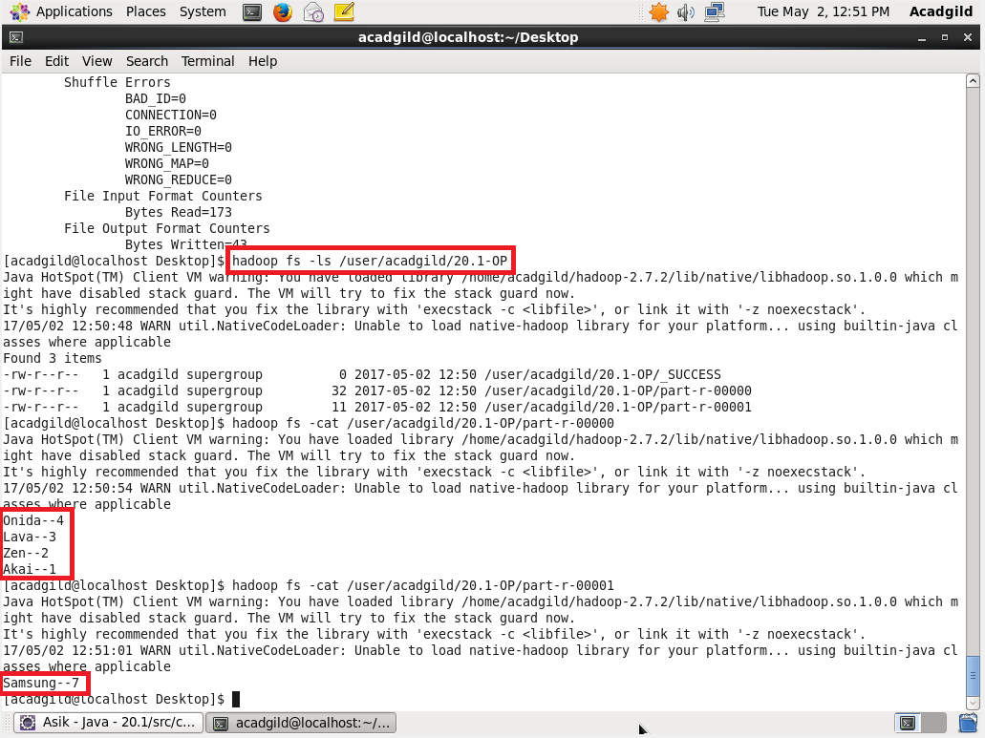

**Companies with total units sold less than 5 went to 1 reducer and others with more than 5 went to second reducer.**